|  |
| --- |
| **Mr.Rakesh Kumar**  **M.Sc. (Chemistry) B.Ed.**  CTET, PSTET, HPTET qualified  thakurkumar82@gmail.com |
| **Class:-XII (Sci.) Name of Student……………………**  **Subject:- Chemistry**  **10 year QuStions**  **Chapter-7**  **Chapter-7 (p- block elements)** |

1. 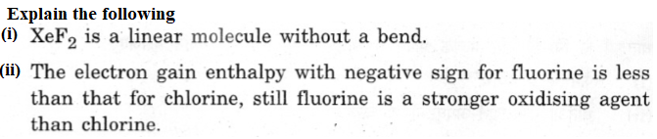
2. Explain (i) SF6 is kinetically inert. (ii) Sulphur has greater tendency for catenation than oxygen.
3. Explain (i) F2 is most reactive of all the four common halogens. (ii) The acidic strength decreases in the order HC*l* > H2S > PH3 (iii) Electron gain enthalpies of halogens are largely negative.
4. Complete the following chemical equations :

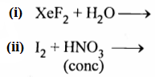

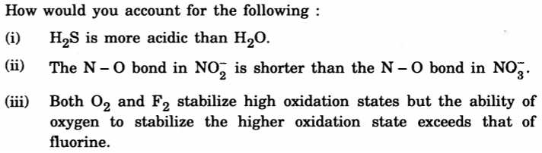

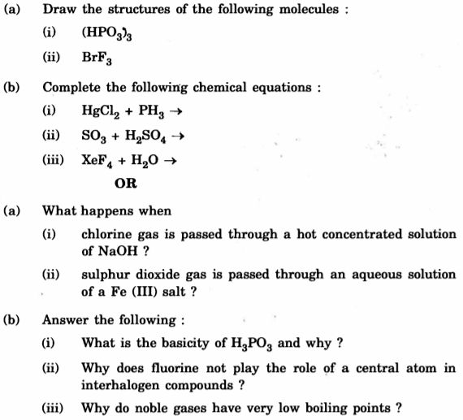6.



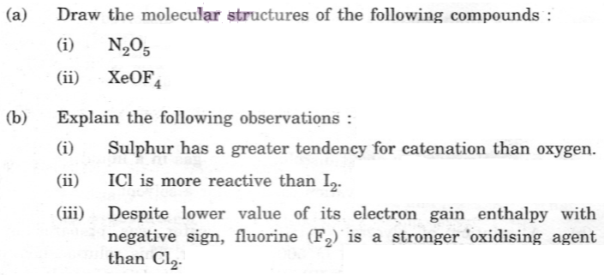

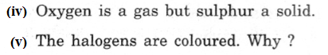

1. Draw the structures of the following : (a) H2SO3 (b) HC*l*O3

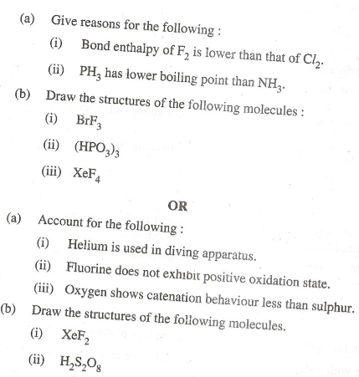

1. How would you account for the following:

(i) Acidic character increases from HF to HI. (ii) There is large difference between the melting and boiling points of oxygen and sulphur.

1. (i) Which allotrope of phosphorus is more reactive and why?

(ii) How the supersonic jet airplanes are responsible for the depletion of ozone layers? (iii) F2 has lower bond dissociation enthalpy than C*l*2. Why? (iv) Which noble gas is used in filling balloons for meteorological observations? (v) Complete the equation: XeF2 + PF5 →

1. Give reasons: (i) Mn show the highest oxidation state of +7 with oxygen but with fluorine it shows the highest oxidation state of +4. (ii) Transition metals show variable oxidation states. (iii) Actinides show irregularities in their electronic configurations.
2. (a) Account for the following :

(i) Ozone is thermodynamically unstable. (ii) Solid PCl5 is ionic in nature. (iii) Fluorine forms only one oxoacid HOF. (iv) C*l*F3 exixts but FC*l*3 does not.

(b) Draw the structure of (i) BrF5 (ii) XeF4

1. (i) Compare the oxidizing action of F2 and C*l*2 by considering parameters such as bond dissociation enthalpy, electron gain enthalpy and hydration enthalpy.

(ii) Write the conditions to maximize the yield of H2SO4 by contact process.

(iii) Arrange the following in the increasing order of property mentioned:

(a) H3PO3, H3PO4, H3PO2 (Reducing character)

(b) NH3, PH3, AsH3, SbH3, BiH3 (Base strength)

1. 

